
Votechain: HYBRID BLOCKCHAIN VOTING DAPP
CN6035 Mobile and Distributed Systems

Name: Sagar Jaishi Sanjyal
Module Code: CN6035
Student Number: 2554846
Table of Contents
1. Introduction 3
2. Project Aim and Objectives 3
Aim 3
Objectives 3
3. System Design and Architecture 4
Frontend Layer 4
Backend Layer 4
Blockchain Layer 4
Wallet Layer 4
4. Smart Contract Development 5
Key Variables 5
Candidate Structure 5
Main Functions 5
addCandidate() 5
startElection() 5
vote() 5
endElection() 6
getWinner() 6
5. Frontend and Backend Implementation 6
Frontend Features 6
Backend Features 6
6. Testing and Evaluation 6
Testing Process 6
Results Summary 6
7. Challenges and Skills Gained 6
MetaMask Network Issues 6
Contract Address Changes 7
Frontend Improvements 7
Skills Gained 7
8. Future Improvements 7
9. Conclusion 8
10. References 8
Step 1: Add Hardhat network to MetaMask 10
Step 2: Import one Hardhat account into MetaMask 11

1. Introduction
Digital technology has transformed many areas of everyday life, including banking, education, healthcare and communication. Voting is another important area that can benefit from digital innovation. Traditional voting systems often depend on paper ballots, manual counting and centralised administration. These methods can be time-consuming, costly and sometimes difficult for people to fully trust. Delays in counting or concerns about manipulation can reduce confidence in election outcomes.
Blockchain technology provides an alternative approach. A blockchain is a decentralised ledger where data is stored securely across multiple nodes. Once information has been recorded, it becomes extremely difficult to alter. This creates transparency, trust and tamper resistance, which are essential features for a voting system.
For this coursework project, I developed VoteChain, a hybrid blockchain voting decentralised application (DApp). The system combines a React frontend, a Node.js backend and a Solidity smart contract deployed through Hardhat. Users connect using MetaMask and cast votes securely through blockchain transactions. The administrator can add candidates, start the election and end the election, after which the winner is calculated automatically.
The project demonstrates how distributed systems concepts can be applied in a practical real-world scenario by integrating modern web technologies with blockchain infrastructure.

2. Project Aim and Objectives

Aim
The main aim of this project was to build a secure and user-friendly voting application that uses blockchain technology to improve trust, fairness and transparency.

Objectives
The objectives of the project were:
- To create a professional frontend dashboard using React.
- To develop a Solidity smart contract for election logic.
- To connect user wallets through MetaMask.
- To allow the administrator to manage candidates and election status.
- To enable users to cast one secure vote.
- To display live results and the final winner.
- To demonstrate a hybrid distributed system using frontend, backend and blockchain technologies.

3. System Design and Architecture
Vote Chain was designed using a hybrid architecture. Instead of using only blockchain, the system combines decentralised features with a traditional web structure. This creates a more practical and scalable solution.

Frontend Layer
The frontend was built using React.js. It handles the user interface, page navigation, candidate display and vote interactions.

Backend Layer
The backend was developed using Node.js and Express.js. It provides API support and demonstrates client-server communication.

Blockchain Layer
The blockchain layer uses a Solidity smart contract deployed on the Hardhat local development network. It stores candidate data, vote records and election status.

Wallet Layer
MetaMask is used for wallet authentication and transaction approval.
This layered structure helped me understand how distributed systems can integrate several technologies into one complete application.
Express Backend
MetaMask Wallet
React Frontend

Smart Contract

Hardhat Blockchain

4. Smart Contract Development
The smart contract is the most important part of the system because it controls all voting operations.

Key Variables
- owner – stores the administrator wallet address.
- candidatesCount – total number of candidates.
- electionStarted – checks if voting has begun.
- electionEnded – checks if voting has finished.

Candidate Structure
Each candidate stores:
- Candidate ID
- Name
- Party
- Number of votes

Main Functions

addCandidate()
Allows only the owner to add candidates before the election begins.

startElection()
Changes the election status to active.

vote()
Allows users to vote once only. Each vote is stored permanently on the blockchain.

endElection()
Stops voting and closes the election.

getWinner()
Calculates the candidate with the highest vote total.
These functions ensure that the election process remains fair, transparent and secure.
Screenshot of Solidity contract code in VS Code.
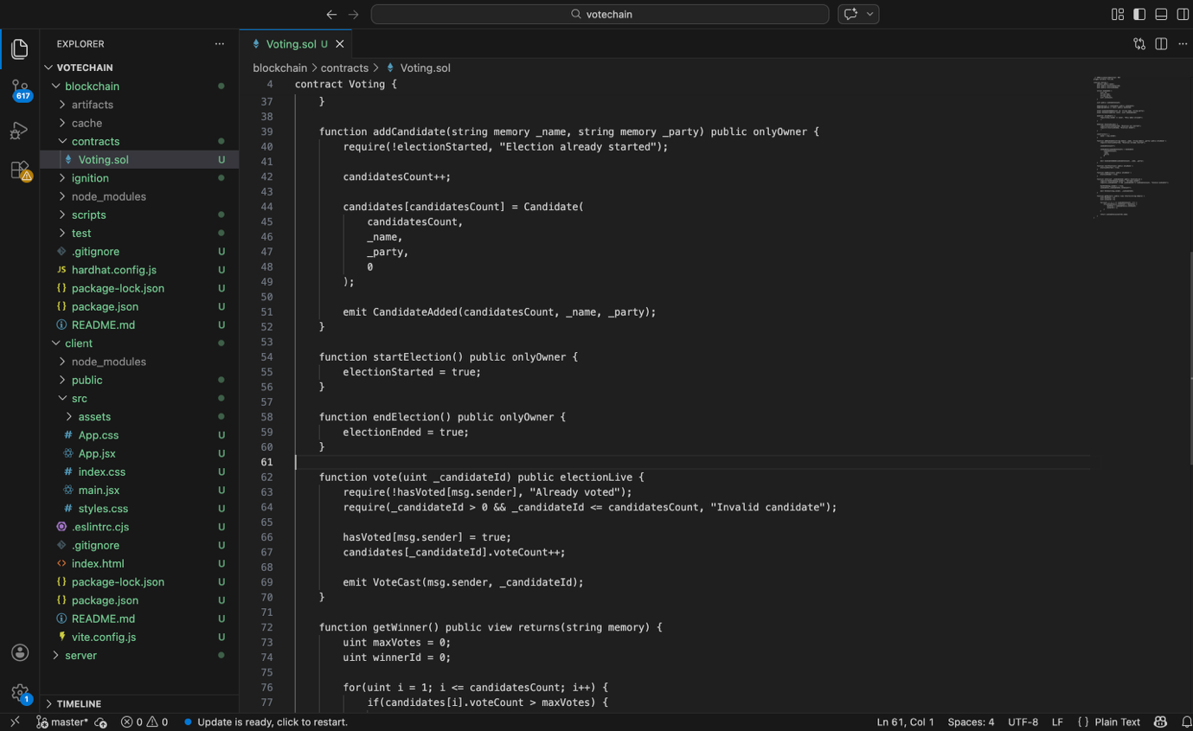

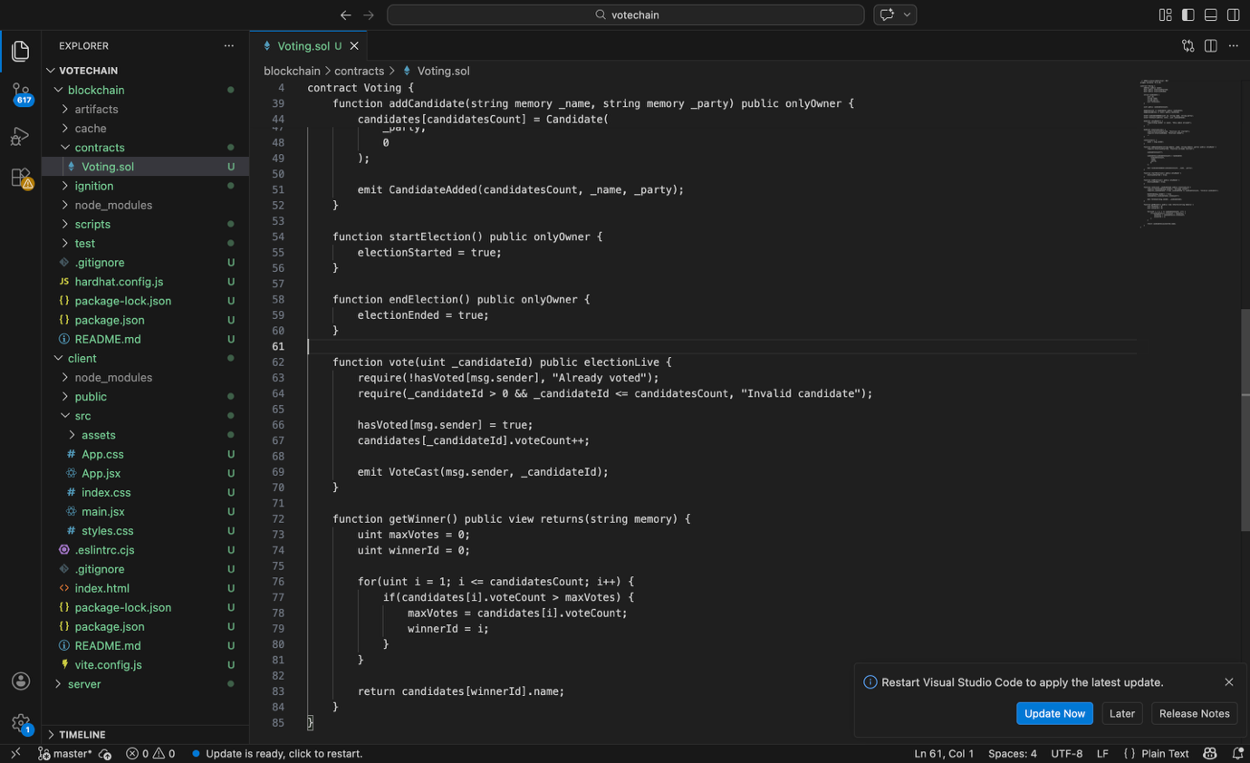

5. Frontend and Backend Implementation
The frontend was designed to look modern and professional while remaining simple to use.

Frontend Features
- Sidebar navigation
- Dashboard statistics cards
- Candidate voting section
- Admin panel
- Results panel
- Hover effects
- Toast notifications
- Loading spinner
The dashboard displays useful live information such as total candidates, total votes, election status and winner.
The admin panel allows the owner to add candidates and control the election process.
The candidate section displays all candidates with vote buttons.

Backend Features
The backend server provides election information through API endpoints and can be extended later with databases, analytics or user management.
Example endpoint:
GET /api/election
This hybrid design makes the project more realistic and closer to real business systems.
📷 Figure 5: Suggested Image
Admin panel showing Add Candidate form.
📷 Figure 6: Suggested Image
Candidates panel showing voting cards.

6. Testing and Evaluation
The application was tested using the Hardhat local blockchain network.

Testing Process
- Connected MetaMask wallet.
- Added candidates successfully.
- Started the election.
- Submitted votes through wallet transactions.
- Vote counts updated correctly.
- Ended the election.
- Winner displayed automatically.

Results Summary
Test Case | Status
Wallet Connection | Pass
Add Candidate | Pass
Start Election | Pass
Vote Submission | Pass
Vote Count Update | Pass
End Election | Pass
Winner Display | Pass
The system performed reliably during testing and met the main project objectives.
📷 Figure 7: Suggested Image
MetaMask transaction approval popup.
📷 Figure 8: Suggested Image
Results panel showing final winner.

7. Challenges and Skills Gained
Several challenges were encountered during development.

MetaMask Network Issues
At first, MetaMask was connected to the wrong network, which prevented transactions. This was fixed by configuring the Hardhat local network.

Contract Address Changes
Whenever the Hardhat node restarted, the smart contract had to be redeployed and the frontend contract address updated.

Frontend Improvements
The user interface was redesigned multiple times to create a cleaner and more professional appearance.

Skills Gained
This project improved my knowledge in:
- React frontend development
- Smart contract programming
- Blockchain transactions
- Full-stack integration
- Debugging and problem solving
Terminal showing contract deployment address.
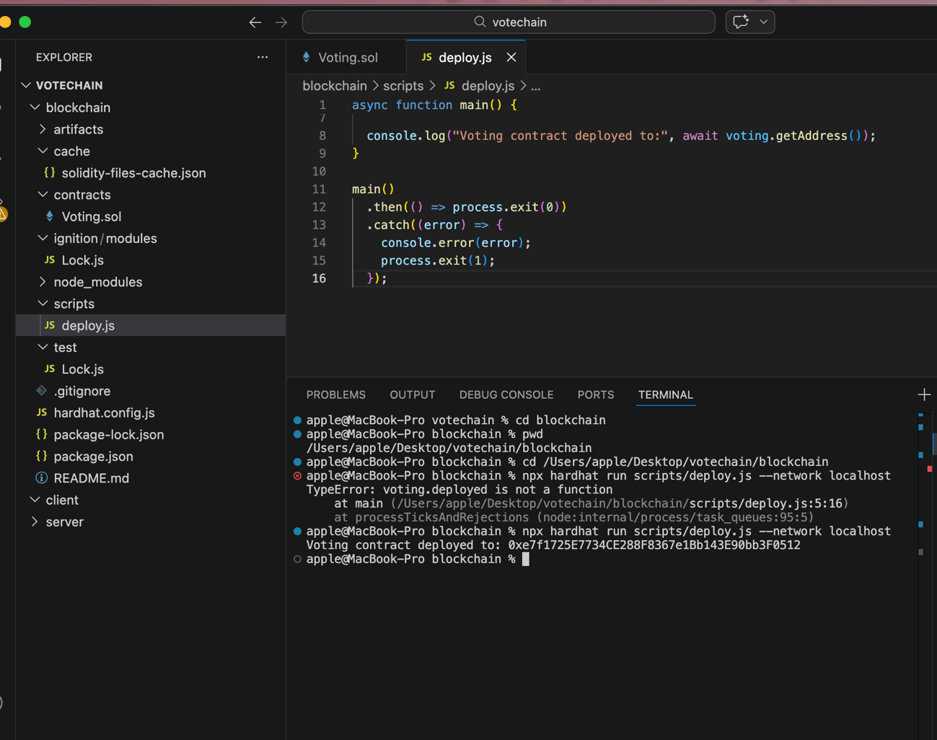

8. Future Improvements
Although VoteChain is functional, several improvements could be added in the future:
- Deploy to Ethereum Sepolia testnet
- User registration database
- Email verification
- Mobile version of the application
- Live charts and analytics
- Multiple election support
- Biometric or ID verification
These features would make the system more suitable for real-world deployment.

9. Conclusion
In conclusion, VoteChain successfully achieved the objective of developing a hybrid blockchain voting application. The project combines a React frontend, Node.js backend and Solidity smart contract into one complete distributed system.
Users are able to vote securely through MetaMask while the administrator manages candidates and election status. Blockchain technology ensures trust, transparency and tamper resistance. The modern frontend also improves user experience and presentation quality.
This project was a valuable learning experience because it combined software development skills with decentralised technologies. It demonstrates how distributed systems can be used to solve real-world challenges such as secure digital voting.
📷 Figure 10: Suggested Image
Final screenshot of the completed VoteChain application.

10. References
Antonopoulos, A.M. and Wood, G. (2018) Mastering Ethereum. Sebastopol: O’Reilly Media.
Buterin, V. (2014) Ethereum Whitepaper. Available at: https://ethereum.org (Accessed: 20 April 2026).
Flanagan, D. (2020) JavaScript: The Definitive Guide. 7th edn. Sebastopol: O’Reilly.
Nakamoto, S. (2008) Bitcoin: A Peer-to-Peer Electronic Cash System. Available at: https://bitcoin.org/bitcoin.pdf (Accessed: 20 April 2026).
Robson, E. and Freeman, E. (2014) Head First Design Patterns. Sebastopol: O’Reilly.
Top of Form

Bottom of Form

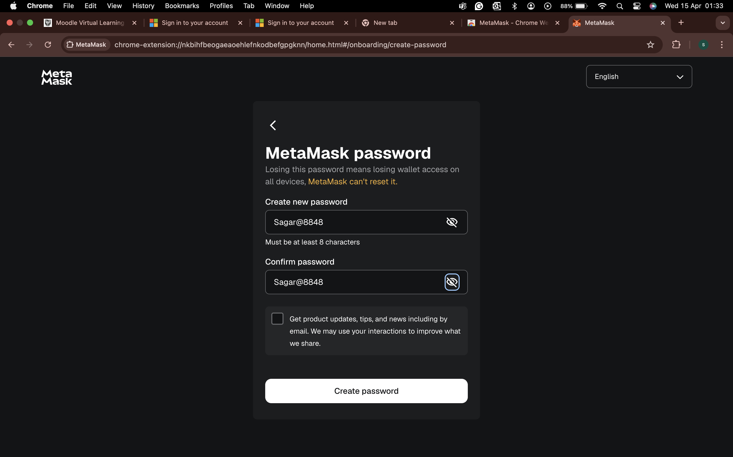

Your contract address is:
0xe7F1725E7734CE288F8367e1Bb143E90bb3F0512
Now we move to the next stage: connect MetaMask and build the frontend.

Step 1: Add Hardhat network to MetaMask
Open MetaMask and add a custom network with these values:
Network Name
Hardhat Local
RPC URL
http://127.0.0.1:8545
Chain ID
31337
Currency Symbol
ETH

Step 2: Import one Hardhat account into MetaMask
Use this private key from your local Hardhat node:
0xac0974bec39a17e36ba4a6b4d238ff944bacb478cbed5efcae784d7bf4f2ff80
This is only for your local test network.
After importing, you should see 10000 ETH in MetaMask on the Hardhat Local network.

